Ryan Harty

9/26/19

Database Management

1.

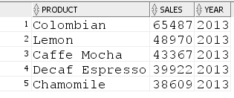

2.

I found budgeted sales equal to 100 or more, but I interpreted the 200% as two times the budget sales. I believe that if it were 300% it would have to be multiplied by three (X1 = same, X2 = 100% more, X3=200% more). But when I multiplied by three there were no answers, so I interpreted the question as twice as much.

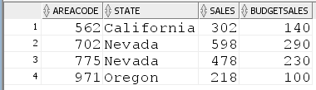

3.

For this question I found the total monthly sales for each month in the year of 2012. I then took the average of those months. The average of all of the months over the year was 33429.92. If I multiplied this number by three than no months would have been greater. So I only look at the months that had sales greater than the monthly average from the year 2012.

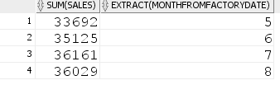

4.

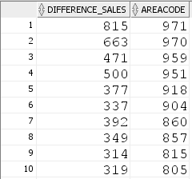

5.

